Pretty Perennials Bendi Card
Presented by Karen Hadler
Supplies  Stamps: Pretty Perennials  Ink: Coastal Cabana, Daffodil Delight, Magenta Madness, Memento Black  Card/Paper, Basic Black, Basic White, Granny Apple Green, Magenta Madness, Coastal Cabana, Daffodil Delight, True Love DSP  Accessories: Gold Glitter Enamel Dots, Lady Bug Trinkets  Tools: Painted Texture 3D Embossing Folder, Perennials Petals Dies, Curvy Dies, Trimmer, Cut and Emboss Machine. Bone Folder, Small Bloom Punch.  Other: Dimensionals, All purpose Glue and Tape. Glue Dots
  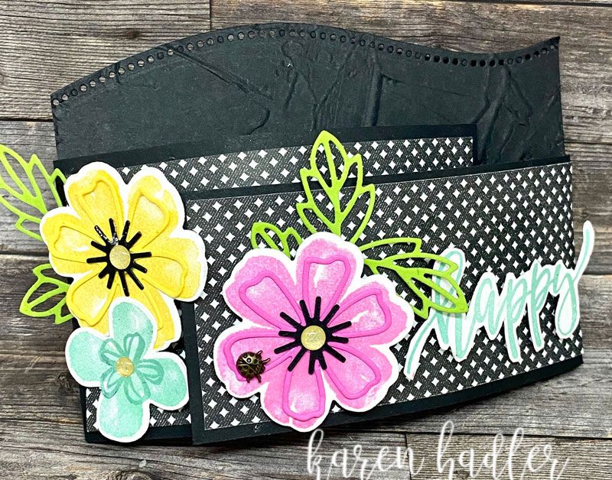
Instructions
- Using the Basic Black piece 10.5 x 14cm and The Curvy Die Cut along the long top edge then run though with the Painted Texture 3D Embossing Folder.
- Score Both Basic Black pieces 13.2 x 7cm and 13.2 x 6 cm at 1 cm down the short edges. Adhere this 1 cm strips to the back of the embossed piece with the larger piece going on the left.
- Then Adhere the 6.5 x 11.7cm True Love DSP to the larger Basic Black and the 5.5 x 11.7 cm DSP to the smaller Basic Black. With your Bone Folder curve each panel inwards.
- Stamp a large Flower in Magenta Madness and Daffodil Delight and a smaller Flower in Coastal Cabana. On the Small Flower also using Coastal Cabana stamp the inner.
- Die Cut the large Flowers and an inner flower shaped piece in Magenta Madness and Daffodil Delight. Also die cut out the smaller Flower and the leaves x2 in Granny Apple Green. Plus 2 x Basic Black inners as shown.
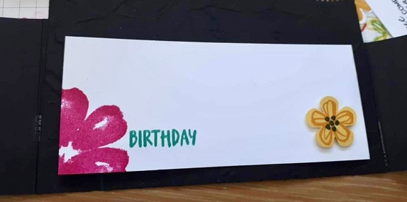
- Stamp a small Flower as shown on Daffodil Delight Cardstock Use the Small Bloom Punch to Cut out.
- Stamp the word Happy on Basic. White and Fussy Cut out.
- On the Basic White 5.5 x 12.5 cm Stamp the large Flower in Magenta Madness as shown. Birthday in Coastal Cabana
- Pop the Punched out Flower in the Bottom right hand
corner up on a large dimensional this will allow the left panel to be tucked under. Adhere to inside of card.
- Place Flowers on Dimensionals, adhere as shown Arrange leaves and Glue in place.
- Adhere the Word Happy with Dimensionals as shown.
- Adhere the Daffodil Delight Die Cut and Black Inner to matching Flower and repeat for the Magenta Madness.
- Finish with Gold Glitter Enamel Dot in the center of Flowers and Glue dot the Lady Bug.
- Tuck the left hand side under inside flower and right hand side under large flowers.

Happy Crafting

